

**Project Report**

**on**

**PHP BLOG WEBSITE**

Submitted to

**LOVELY PROFESSIONAL UNIVERSITY**

for

**INT 220 SERVER SIDE SCRIPTING**

**Submitted By Submitted to**

**Sudeep Kumar Dr. Vivek Bhardwaj**

**11917205 Assistant Professor**

**LOVELY FACULTY OF TECHNOLOGY & SCIENCES**

**LOVELY PROFESSIONAL UNIVERSITY**

**PUNJAB**

**April 2022**

**Table of Contents**

**Chapter Particulars Page No.**

1. Introduction 3
2. Technologies used 4-6
3. Modules 6-9
4. Website snapshots 10-14
5. GitHub link 15

References 15

**CHAPTER 1**

**INTRODUCTION**

* 1. **Introduction**

As we know we are in the modern era of technology and Website development is one of the major concern in present time and also will be in the coming future. We cannot imagine our life without websites and mobile application . Some of the great example like Google , Facebook , Instagram are those platforms which become the integral part of our day to day life. So it is very important that one should know about the technology related to the development of things like that.

In this project we are going to discuss about the project named “Blog Website” which is completely made on one of the famous programming tool which is being used in the field of development called PHP . In this project we use the functionality of the php to do different things related to website like Signup, Signin, Creating Blog, Updating Blog , Reading Blog , Deleting Blog and many other stuffs. This project deals with the basic implementation of the language and their inbuilt functions which make our life very easy to build and execute many complex website. We are also going to see different types of inbuilt feature related to Designing, Authentication, Routing available in the php language which will do our work very easily.

In this project we also discuss about the one of the most important aspect of any project which is databases and how to handle it with the help of language itself by using some connector.

Php provide a great amount of inbuilt function and logics which will do our work like Creating entry, Reading Entry, Updating Entry as well as Deleting Entry in the databases very easily without writing that much hectic queries for doing all that thing. Going forward this project contain certain Chapters for the detailed description of the implementation of the project which will definitely make us understand a great deal of php language and its functionality , and we become ready to work in this language in the coming future.

**CHAPTER 2**

**TECHNOLOGY USED IN PROJECT**

This project uses various technologies. Since this project is based on Web, So mostly it used web technologies.

The technologies used are mention below:

* 1. **HTML (Hyper Text Markup Language)** : It is a markup language used to design web pages and can be understood by HTTP or HTTPS Protocols. It consists of number of tags which is used to give the basic structure to the web pages. It is also very much demanding in the real world as in this modern world, we can say most of the things are based on internet and websites and it is a building block of any websites. Facebook, Twitter, Amazon are some of the big websites using this technology. In this project it is again used as building block of our webpages.
  2. **CSS (Cascading Style Sheets) :** It is a language used in websites to style the webpages and give them attractive looks. It is used to give every element of style we can think of to the webpages like animation, transition , designing , etc…. All the design in this project is created by using this CSS . In real world again this is also very useful. You can go to any website and you see you will find it attractive , there are various transition effect and also various animations . You see different styled button, links , Nav-bars , etc. This all is done with the help of the CSS.
  3. **Bootstrap:** It is a framework which help us to design websites faster and easier . It includes HTML and CSS based design templates for typography, forms, buttons, tables, navigation, modals, image carousels, etc . It also give support for JavaScript plugin . It also let us do some external changes if we want to in the designing which is offered by it by default. In this project some of the bootstrap is there which help in the design of some of the components there. In real world since it give inbuilt design template to the user it is very much useful. Since developer donot need to do all things with scratch they just need to take the template and modify it as per their requirement and need.
  4. **PHP :** PHP is an open-source server-side scripting language that many devs use for web development. It is also a general-purpose language that you can use to make lots of projects, including Graphical User Interfaces (GUIs). In this project php is used as a internal language in the laravel framework. Since laravel framework based on the php language it is important for us to know the basic functionality of the php programming language
  5. **MySQL** : MySQL is a widely used relational database management system (RDBMS). MySQL is free and open-source. MySQL is ideal for both small and large applications. It is a widely used database management system which stores data in the form of table so that user can able to understand and manage the data efficiently.In this project we use this database for proper storing of the Blog Created and it will store many different types of information related to data like timestamp, a slug heading etc. It is also used to store the authentication data of any user signing up or login in .Due to its effectiveness and clarity it provide it is used in this project.
  6. **Git** : Git is software for tracking changes in any set of files, usually used for coordinating work among programmers collaboratively developing source code during software development. Its goals include speed, data integrity, and support for distributed, non-linear workflows (thousands of parallel branches running on different systems. Git was originally authored by Linus Torvalds in 2005 for development of the Linux kernel, with other kernel developers contributing to its initial development. Since 2005, Junio Hamano has been the core maintainer. As with most other distributed version control systems, and unlike most client–server systems, every Git directory on every computer is a full-fledged repository with complete history and full version-tracking abilities, independent of network access or a central server. Git is free and open-source software distributed under the GPL-2.0-only license.
  7. **XAMPP** : XAMPP is an abbreviation where X stands for Cross-Platform, A stands for Apache, M stands for MYSQL, and the Ps stand for PHP and Perl, respectively. It is an open-source package of web solutions that includes Apache distribution for many servers and command-line executables along with modules such as Apache server, MariaDB, PHP, and Perl.

XAMPP helps a local host or server to test its website and clients via computers and laptops before releasing it to the main server. It is a platform that furnishes a suitable environment to test and verify the working of projects based on Apache, Perl, MySQL database, and PHP through the system of the host itself. Among these technologies, Perl is a programming language used for web development, PHP is a backend scripting language, and MariaDB is the most vividly used database developed by MySQL.

**CHAPTER 3**

**MODULES**

**3.1 Login**

The first module in this project is the login module. Login is one of most important thing as per the authorization is concerned. It provide the security that nobody unauthorized will come and do anything with the data hence it is very important for the user. In this project we are using the auto inbuilt login module which is created by the php Language. All the functioning regarding login like creating the database, putting entry in the database, checking the user for verification is handled by different functionality provided by the langauge. It provide a great ease for the developer to take care of this authentication. In the login screen there is input field where user have to enter the credential and then if credential matched he will logged in and routed to the desired page else there is an error thrown by the language. This all views are created using html css and php using their respective functionality.

**3.2 Signup**

It is the second module in which the user can able to create the account if he or she have no any account in the website. This is also very important as per the security purpose as we don’t want any unknown to come and create stuffs in website so signup will provide a way that only particular user will be able to use this blog website .

The signup view is again rendered by html css and javascript including php functionalities, In the signup user required to fill the specific credential like username , emailed, password and after successful filling those fields and applying the data of the user will get stored in the respective database in the sql, and then he or she will be able to create the post and share the thought publically to whosoever he or she want to convey.

Once the user signup he or she will be agree to all terms and condition and then after if the user try to do anything in the website , he or she will be required to verify the credentials with login and then he or she will able to do whatever he or she want in the in their blog website account.

**3.3 Home Page**

This is the third module in this project. Homepage is one of the important element in any website as it describe the overview of the website in a single glance. This project is also have home page where user can able to see the defined User Interface with all the basic details about the website. It is the soul of any website.

The home page of this project is also contains some important information about the website like it contains the blog which is created by anyone in the website. It has several buttons through which anybody can able to login and signup and if wanted would be able to see the blog post also. User can also able to read the detailed view of the blog post appearing there. There is a navigation where user can see the created post , profile etc.

**3.4 Create Blog Page**

This is the fourth module screen of the screen . As it is a blog website user must be able to create the blog as per his or her wish. This create page give multiple functionality to create the blog post. For creating a blog the user should give some basic inputs like Blog Title which will show the title of the blog , user should give description of the post in which user describe about the post and give a proper content about the post to understand the context. Then user should upload a picture file related to this blog, which will describe the post in a single view. Whether user want to make private or public blog , After providing all the inputs to the required field and submitting the data the post will be created and move forward to the home screen so that it will be available for other to see and get the information.

As described above that user are providing several information in the post creation all the data are stored in the database which will be created by the user in this case the heading is stored as the slug in the database for the proper identification, and with this it will store the description and the timestamp too which will sort the post as per recent upload. All this structure is very useful while retrieving the data for the view in the interface.

Note : Only user with account can able to create the blog in the website , no other user will be able to do this since it is not allowed as per the security rules of authentication.

**3.5 Blog Detailed View**

This is the fifth module related to this project. It deals with the detailed description of the blog created . As the user create the blog it will be available in the home page for the overview. But if one want to read the blog in detail user can able to switch to the detail view page where all the details are saved in details and user can able to understand more about the blog and can able to retrieve more information about the blog , and this is what the main purpose of any blogger. In details view there is three buttons where user can able to go back , edit the blog or delete the blog.

**3.6 Blog Edit View**

This is the sixth module of this project. It deals with the update of the blog details in the website. Sometimes user created the blog and later if he or she think that there is need to add some more details , or to remove any unnecessary things from the blog the user can able to update the blog as per required. This will give the freedom to the user to make their blogs more valuable by providing proper content inside it and if there is any glitch updation is also possible.

In this website in the update section user can able to update multiple field in their blog. User can able to change their heading , description , images or the privacy of the blog whether it is private or public blog and all the changes made also get updated in the database. For which database related functionality in the php programming language is included.

Note : Only user with account can able to update the record in the database , no other user will be able to do this since it is not allowed as per the security rules of authentication.

**3.7 Delete Blog View**

This is the seventh module in this project which provide delete functionality to the user. Delete is one of the important operation user can perform. If any mistake or any unwanted post get posted in the blog section it need to be deleted , hence it help the user to remove those unwanted blog from the account and hence allow the user to keep the blogs section clean and effective. Once clicking on the delete button a confirmation is asked and after giving the confirmation user can able to delete the blog from the website as well as the database.

Note : Only user with account can able to delete the record from the database , no other user will be able to do this since it is not allowed as per the security rules of authentication.

**3.8 Profile Section**

This is the eight module in this project , this provide a interface where all the profile related information is kept in the account. Here user can change the profile related information like First Name and the second name , username and the email id is not allowed to change. In the profile section user can also able to change the account associated password and can able to create a new one . Hence it give a complete freedom with some security to the user to play with the details of his or her account.

**3.9 Logout Screen**

This is the ninth module of this project . Once the user got logged out of his or her account he or she will able to see the confirmation that logout has been done and a beautiful page get rendered to the screen giving that confirmation. In that page there is a button for the navigation to the home screen which the user can use to navigate to the home screen.

**CHAPTER 4**

**SNAPSHOTS**

**4.1 Home page**

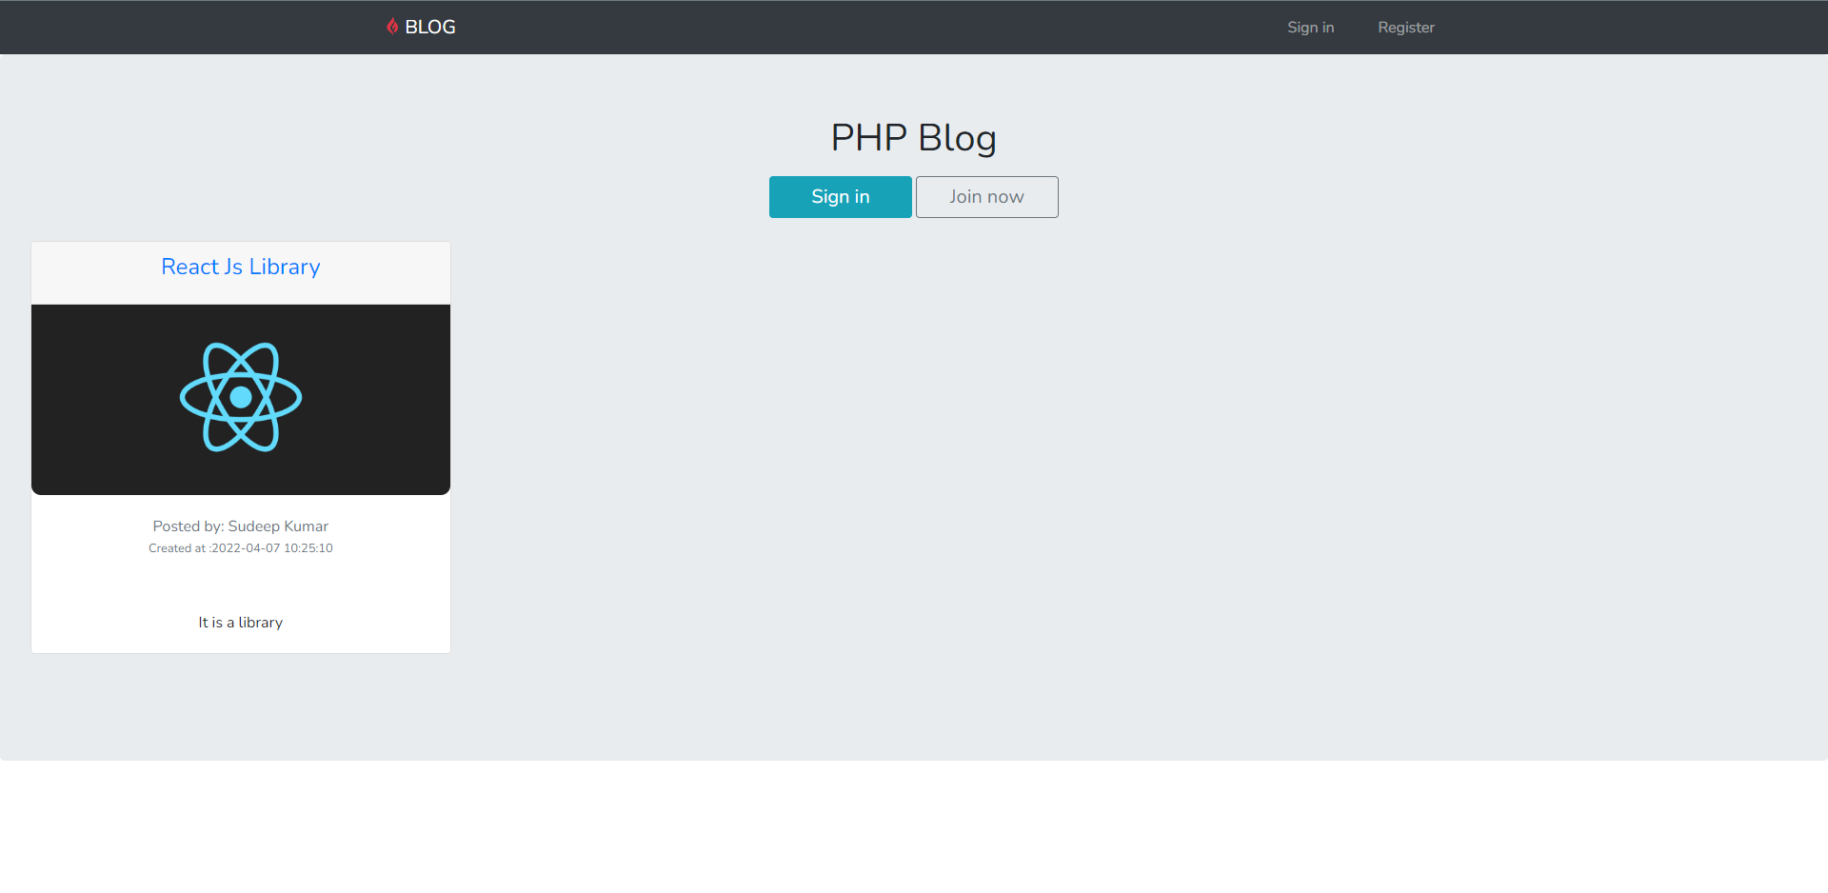

**4.1.1 Landing Page**

**4.2 Sign Up page**

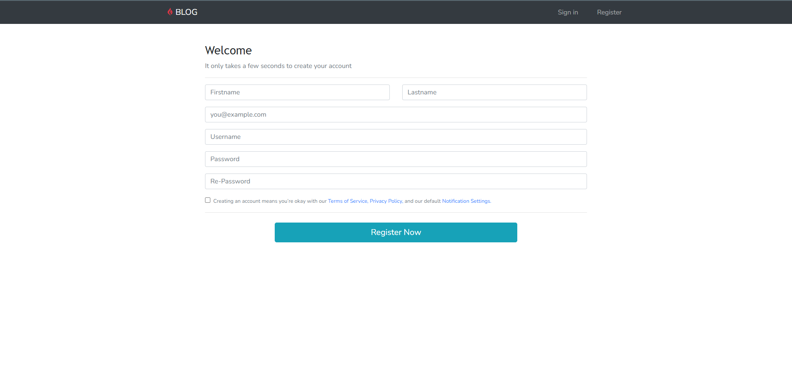

**4.2.1 Sign up page**

**4.3 Sign In page**

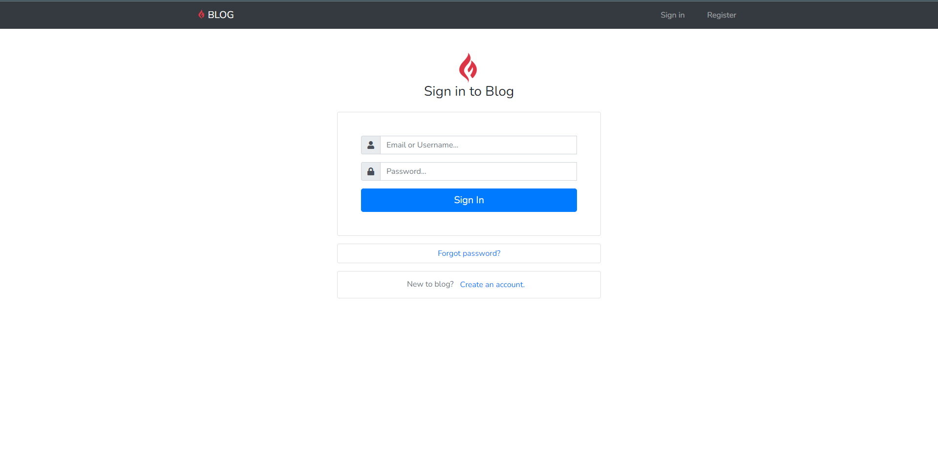

**4.3.1 Sign In page**

**4.4 Blog View Home Page**

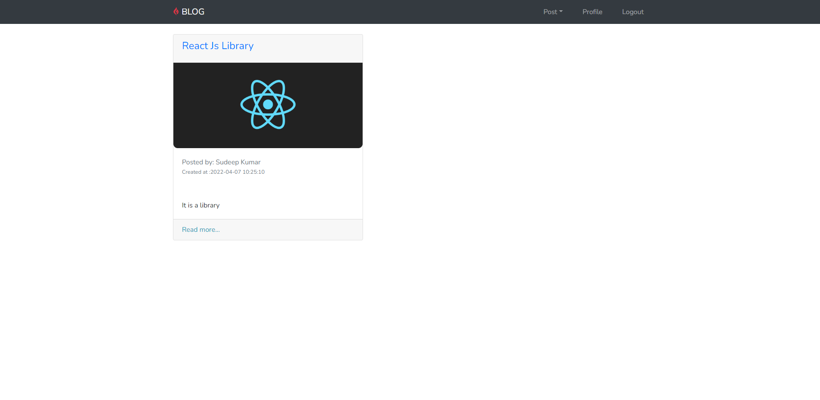

**4.4.1 Blog View Home Page**

**4.5 Create Blog Page**

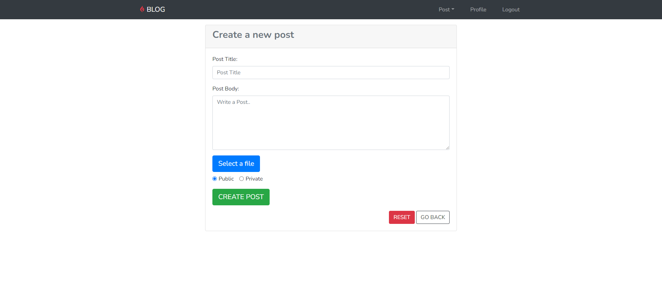

**4.5.1 Create Blog Page**

**4.6 Update Blog Page**

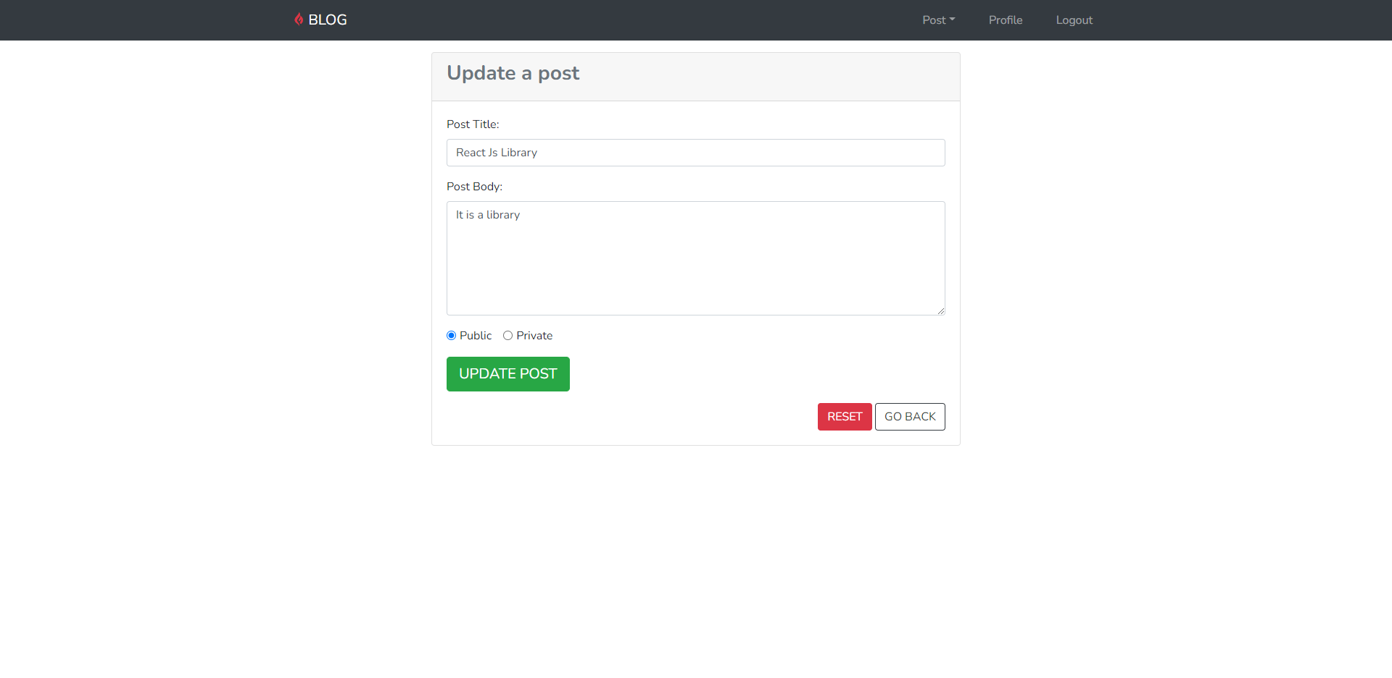

**4.6.1 Update Blog Page**

**4.7 Read Detailed Blog Page**

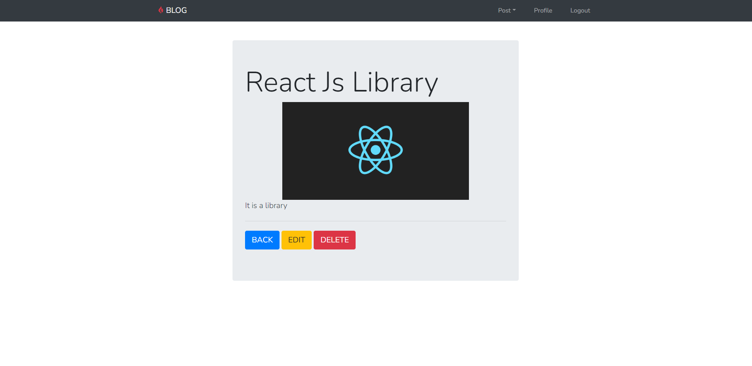

**4.7.1 Read Detailed Blog Page**

**4.8 Delete Blog Page**

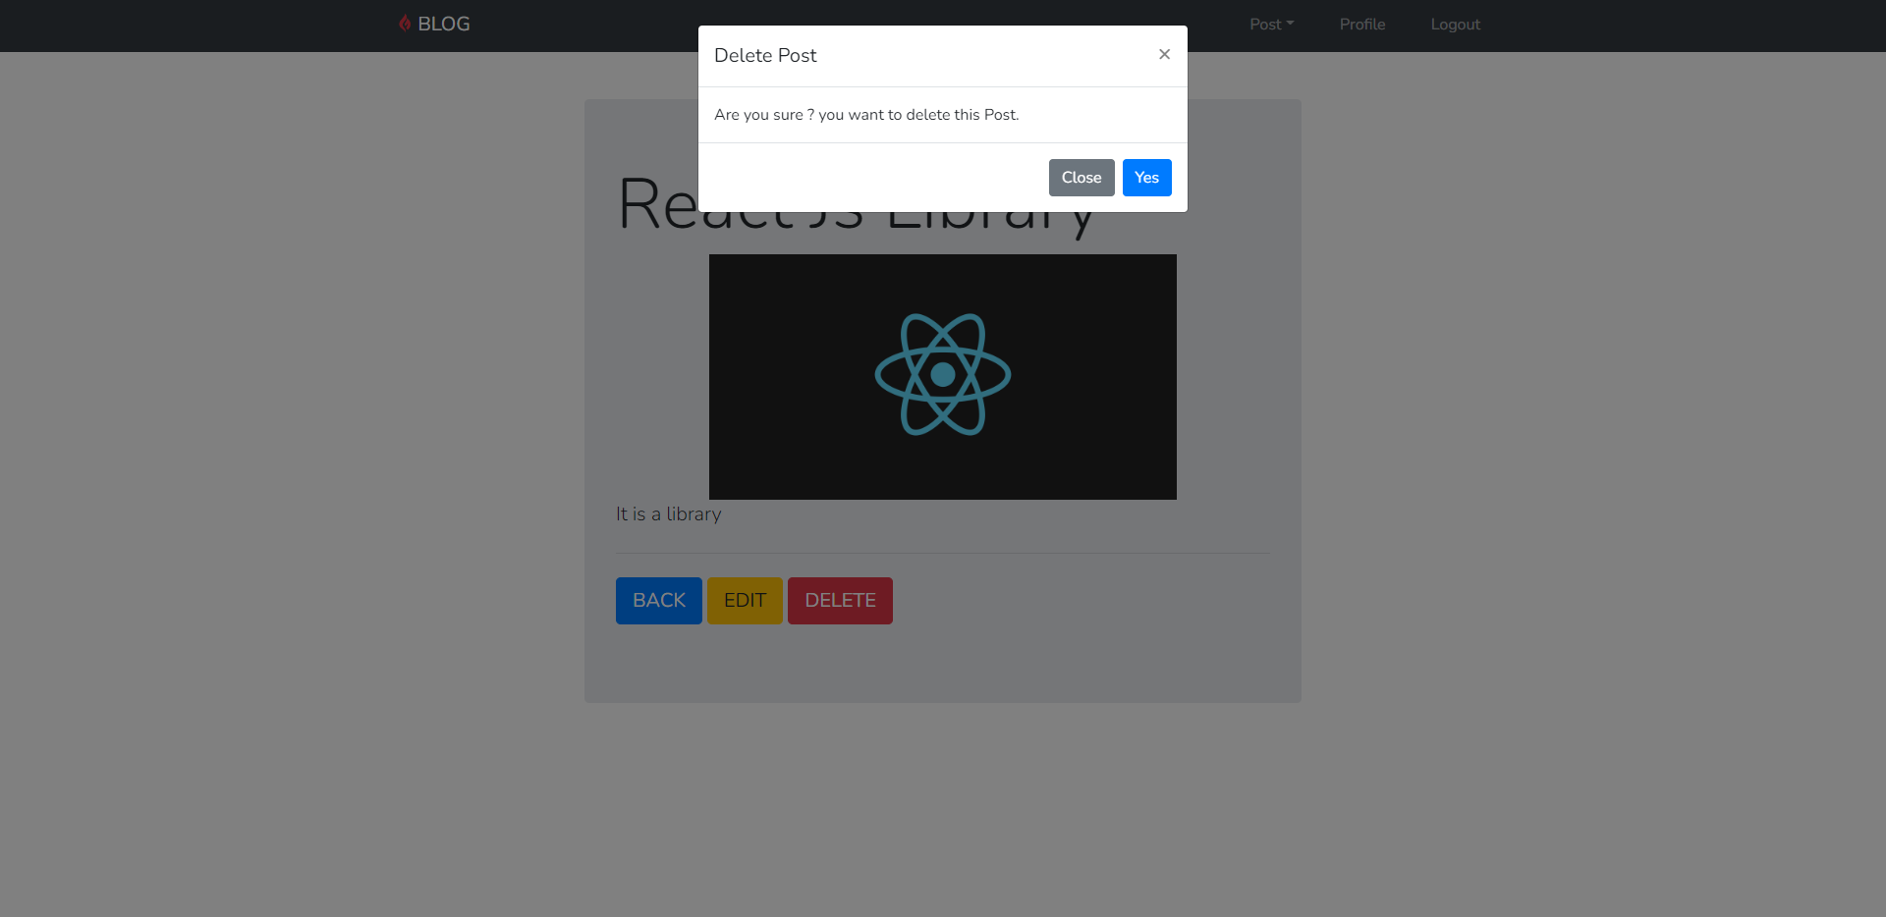

**4.8.1 Delete Blog Page**

**4.9 Profile Section Page**

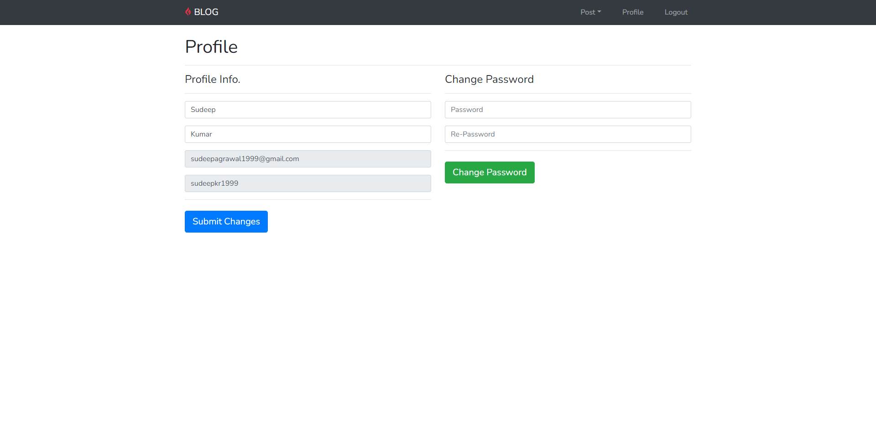

**4.9.1 Profile Section Page**

**4.10 Logout Page**

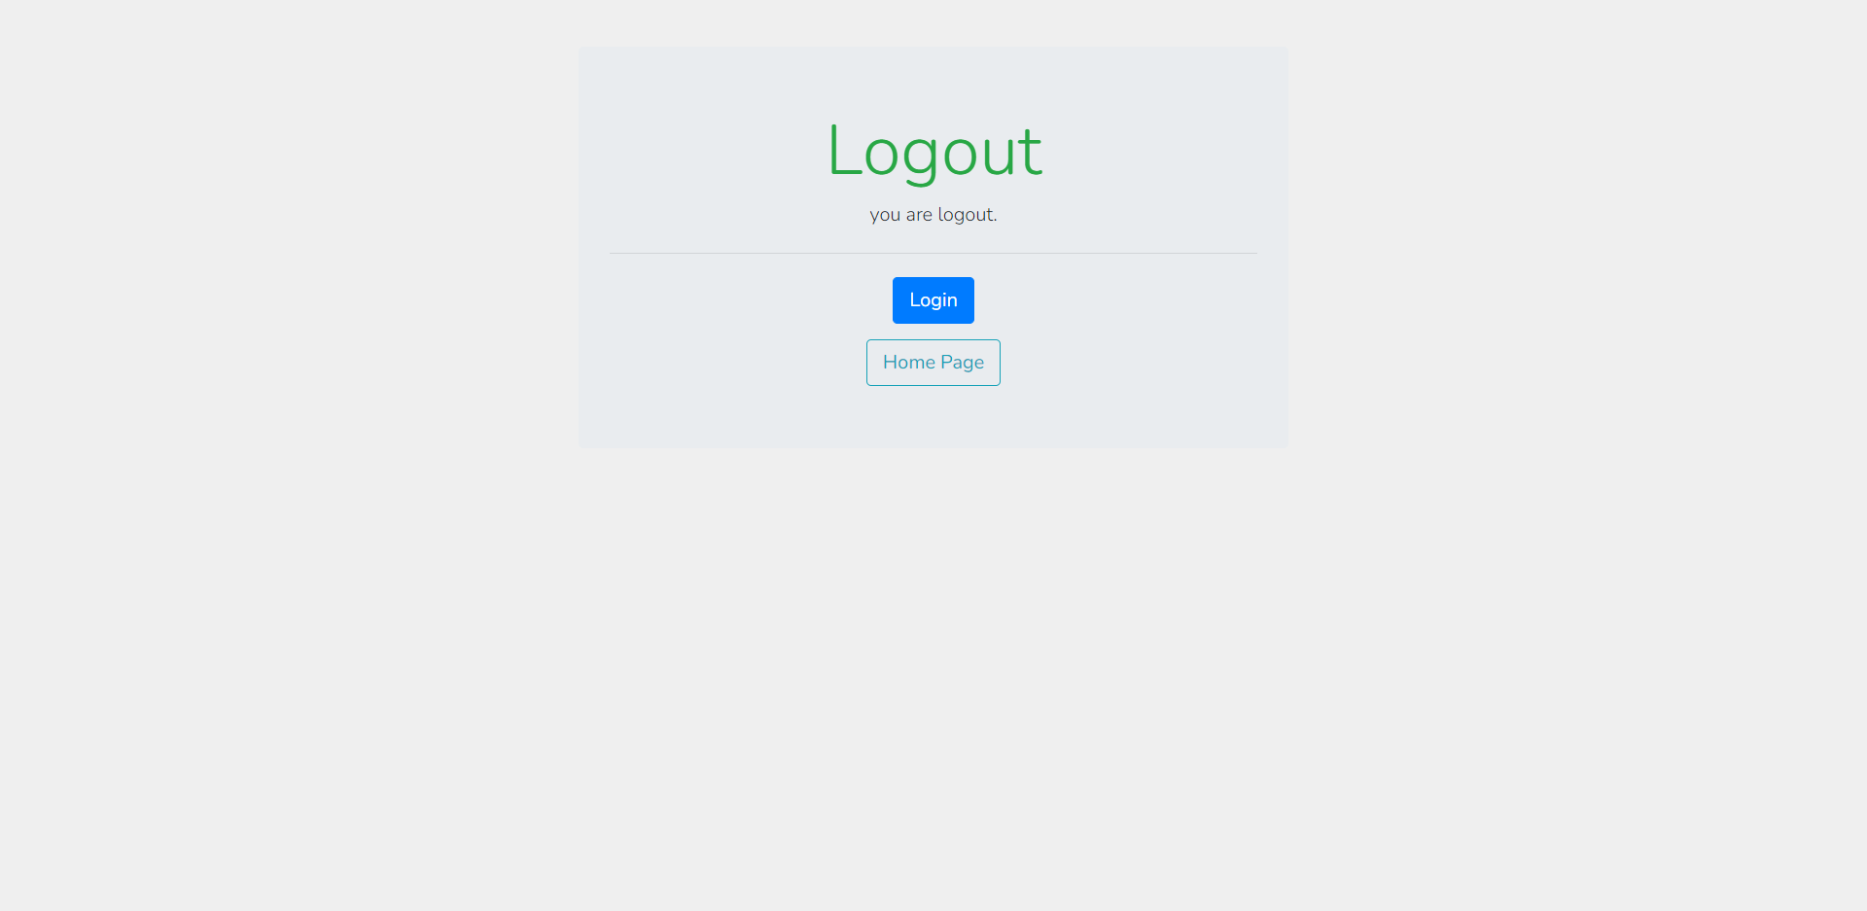

**4.10.1 Profile Section Page**

**CHAPTER 5**

**Github link and References**

**Github link** : <https://github.com/Sudeep-kr-1999/Php-Blog-.git>

**References**

* <https://www.w3schools.com/php/>
* <https://www.w3schools.com/php/php_forms.asp>
* <https://blog.feedspot.com/php_blogs/#:~:text=ViewCompact%20View-,PHP%20Blogs,PHPpot%20Tutorial%20%2D%20Vincy>
* <https://www.php.net/docs.php>

**END**